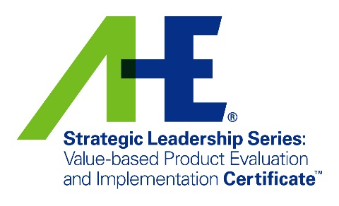

Value-based Product Evaluation and Implementation (VPEI)

Justification Toolkit

Table of Contents
Testimonials 1
Expenses Estimate 2
Justification Letter 3

Testimonials:
Don’t take our word for it — Read the following testimonials from past participants:

“Great program which encouraged critical thinking and emphasized the impact of environmental services professionals in a constantly changing health care environment.”
“Great class! Interactions with others and instructors were engaging and helpful for my everyday work.”
“VPEI is a must take course for managers involved with supply procurement in their organization.”
“The attendee interaction and willing to share their experiences added greatly to the value of the class.”

“The VPEI series provided valuable insight to product evaluation. In addition, the class learned how to present their product evaluation to their target audience. Environmental services managers on all levels will benefit from this class.”

“Awesome program! Amazing instructors.”

“I like the format, a mixture of activity and lecture. I also liked the interaction we could have with the group.”

“Good information on disinfectant types. Nice material on how to do product evaluation. Good analysis on how we present our information to our target audience.”

“Both facilitators were very knowledgeable and did a great job of facilitating the course. The material and group exercises/activities were relevant and beneficial. Overall I was pleased with the course and learned a few new things to bring back to work.”

Expenses Estimate

Airfare | [insert price]
Meals | [insert price estimate]
Hotel | [insert price]
Miscellaneous (travel, etc.) | [insert price estimate]
Registration Fee | [insert price] *see table below
Total | [insert total]

Session Fees
Certificate of Mastery in Infection Prevention (CMIP), AHE Member | $799
Certificate of Mastery in Infection Prevention (CMIP), Non-Member | $999

Dear <Insert supervisor name>:
I am requesting your approval to attend the Value-based Product and Evaluation Implementation (VPEI) workshop, developed by the Association for the Health Care Environment (AHE) of the American Hospital Association (AHA). The information presented in this 2-day course will enable me to deliver value to our organization by impacting clinical and financial outcomes.
VPEI is built to help participants cultivate and demonstrate their ability to analyze, evaluate, influence, and justify cleaning and disinfection decisions that impact patient safety and quality of care. The training will help me lead with confidence and build proposals tailored to the various needs and perspectives of key stakeholders.
I believe the program will support and develop these current initiatives at [insert organization]:
- Initiative 1
- Initiative 2
- Initiative 3
The next VPEI session will take place on [insert date] in [insert city/state].
Cost projection:
Airfare | [insert price]
Meals | [insert price estimate]
Hotel | [insert price]
Miscellaneous (travel, etc) | [insert price estimate]
Registration fee | [insert price]
Total | [insert total]
The Value-based Product Evaluation and Implementation program helps participants and their organizations stay relevant in today’s health care landscape of cost, quality, and outcomes. Attending will boost my knowledge and credibility, and in return transform fundamental decisions from a tactical approach to a strategic one. Your approval and confirmation of the budget would be greatly appreciated.

Sincerely,
<Insert your name>

